Ying-Shan Liang

420-CT1-AS

Computer Tools

Final Exam

Presented to

Zohreh Moeini

**Excel Graphs for results**

**1- Graph for East Region**

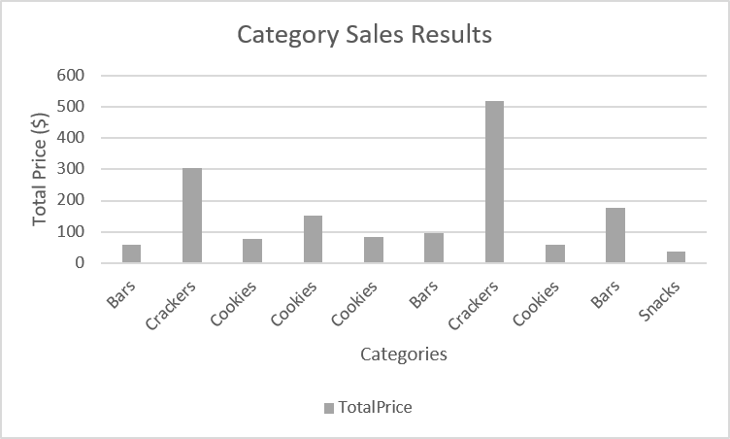

**2- Graph for each category sales results**

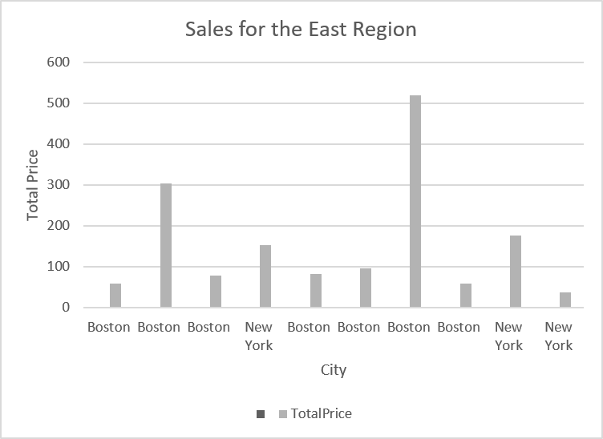

**Tables for results**

Food Sales Data Table

|  |  |  |  |  |  |  |  |
| --- | --- | --- | --- | --- | --- | --- | --- |
| OrderDate | Region | City | Category | Products | Quantity | UnitPrice | TotalPrice |
| 2020-01-01 | East | Boston | Bars | Carrot | 33 | 1,77 | 58,41 |
| 2020-01-04 | East | Boston | Crackers | Whole Wheat | 87 | 3,49 | 303,63 |
| 2020-01-07 | West | Los Angeles | Cookies | Chocolate Chip | 58 | 1,87 | 108,46 |
| 2020-01-10 | East | New York | Cookies | Chocolate Chip | 82 | 1,87 | 153,34 |
| 2020-01-13 | East | Boston | Cookies | Arrowroot | 38 | 2,18 | 82,84 |
| 2020-01-16 | East | Boston | Bars | Carrot | 54 | 1,77 | 95,58 |
| 2020-01-19 | East | Boston | Crackers | Whole Wheat | 149 | 3,49 | 520,01 |
| 2020-01-22 | West | Los Angeles | Bars | Carrot | 51 | 1,77 | 90,27 |
| 2020-01-25 | East | New York | Bars | Carrot | 100 | 1,77 | 177 |
| 2020-01-28 | East | New York | Snacks | Potato Chips | 28 | 1,35 | 37,8 |
| 2020-01-31 | East | Boston | Cookies | Arrowroot | 36 | 2,18 | 78,48 |
| 2020-02-03 | East | Boston | Cookies | Chocolate Chip | 31 | 1,87 | 57,97 |

Sale for the East

|  |  |  |  |  |  |
| --- | --- | --- | --- | --- | --- |
| City | Category | Products | Quantity | UnitPrice | TotalPrice |
| Boston | Bars | Carrot | 33 | 1,77 | 58,41 |
| Boston | Crackers | Whole Wheat | 87 | 3,49 | 303,63 |
| Boston | Cookies | Arrowroot | 36 | 2,18 | 78,48 |
| New York | Cookies | Chocolate Chip | 82 | 1,87 | 153,34 |
| Boston | Cookies | Arrowroot | 38 | 2,18 | 82,84 |
| Boston | Bars | Carrot | 54 | 1,77 | 95,58 |
| Boston | Crackers | Whole Wheat | 149 | 3,49 | 520,01 |
| Boston | Cookies | Chocolate Chip | 31 | 1,87 | 57,97 |
| New York | Bars | Carrot | 100 | 1,77 | 177 |
| New York | Snacks | Potato Chips | 28 | 1,35 | 37,8 |
|  |  |  |  |  |  |
|  |  |  |  |  |  |

Sale results according to each category

|  |  |  |  |  |
| --- | --- | --- | --- | --- |
| Category | Products | Quantity | UnitPrice | TotalPrice |
| Bars | Carrot | 33 | 1,77 | 58,41 |
| Crackers | Whole Wheat | 87 | 3,49 | 303,63 |
| Cookies | Chocolate Chip | 58 | 1,87 | 108,46 |
| Cookies | Chocolate Chip | 82 | 1,87 | 153,34 |
| Cookies | Arrowroot | 38 | 2,18 | 82,84 |
| Bars | Carrot | 54 | 1,77 | 95,58 |
| Crackers | Whole Wheat | 149 | 3,49 | 520,01 |
| Bars | Carrot | 51 | 1,77 | 90,27 |
| Bars | Carrot | 100 | 1,77 | 177 |
| Snacks | Potato Chips | 28 | 1,35 | 37,8 |
| Cookies | Arrowroot | 36 | 2,18 | 78,48 |
| Cookies | Chocolate Chip | 31 | 1,87 | 57,97 |

|  |  |  |  |  |  |  |  |  |
| --- | --- | --- | --- | --- | --- | --- | --- | --- |
|  |  |  |  |  |  | | | |
|  |  |  |  |  |  |  |  |  |
|  |  |  |  |  |  |  |  |  |
|  |  |  |  |  |  |  |  |  |
|  |  |  |  |  |  |  |  |  |
|  |  |  |  |  |  |  |  |  |
|  |  |  |  |  |  |  |  |  |
|  |  |  |  |  |  |  |  |  |
|  |  |  |  |  |  |  |  |  |
|  |  |  |  |  |  |  |  |  |
|  |  |  |  |  |  |  |  |  |
|  |  |  |  |  |  |  |  |  |
|  |  |  |  |  |  |  |  |  |